**GROUP 8:**

**BAGADIONG**

**FAJARDO**

**MACHINE PROBLEM #4 (MATLAB SOLUTION)**

**Test #1:**

Input values for test #1: 30, 10, 30, 2, 5

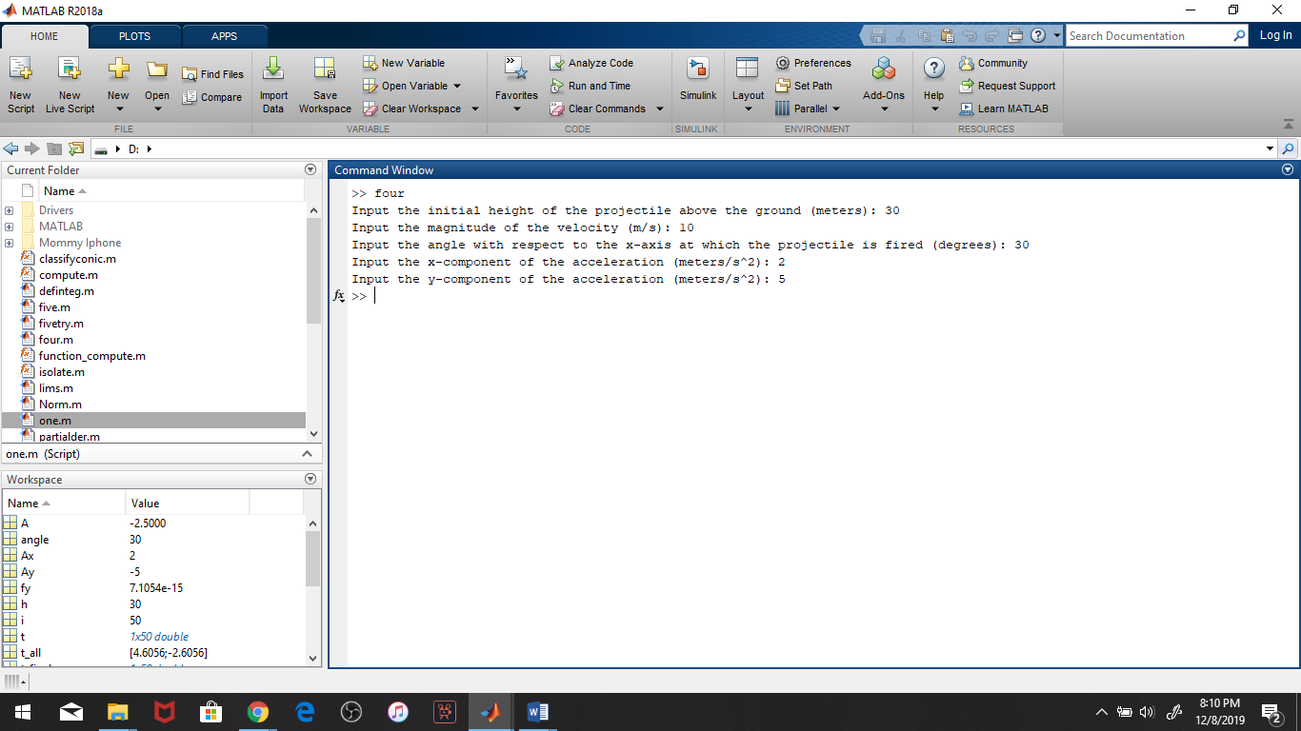

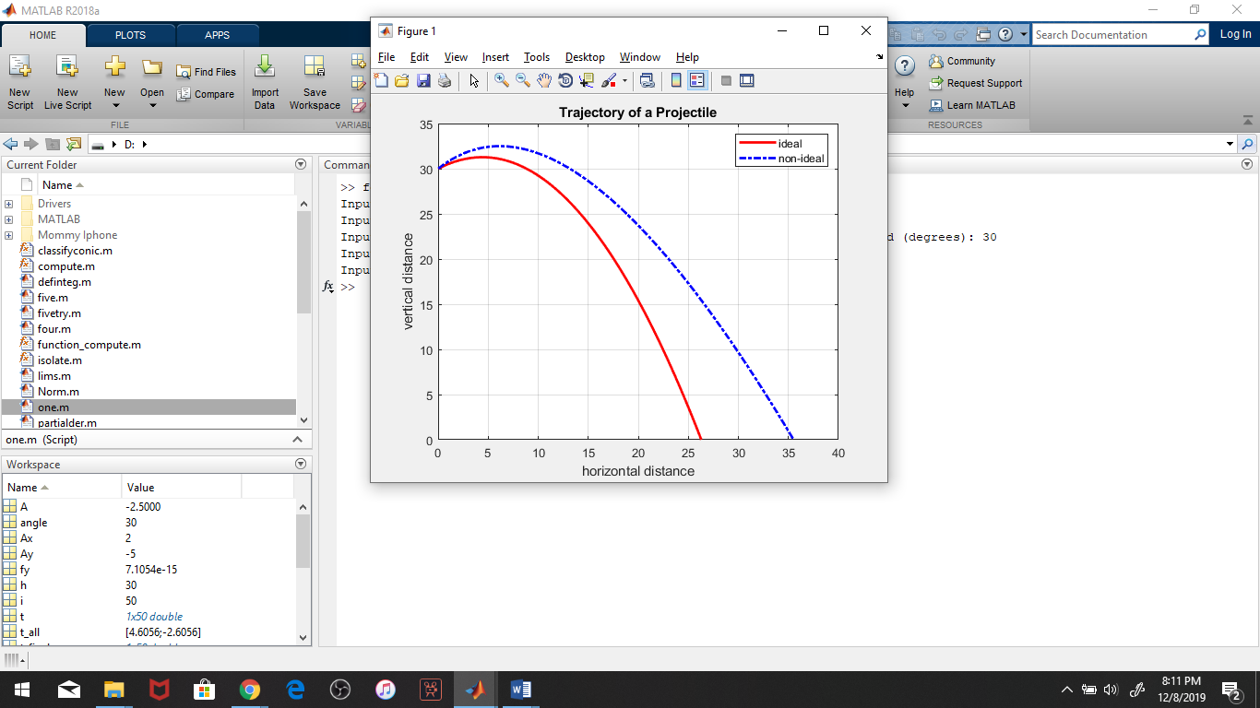

**Test #2 (including error message for Ay = 0):**

Input values for test #1: 100, 45, 25, 2, 27

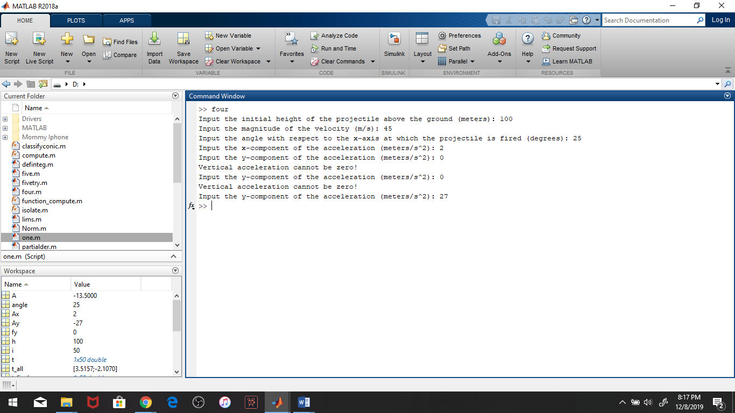

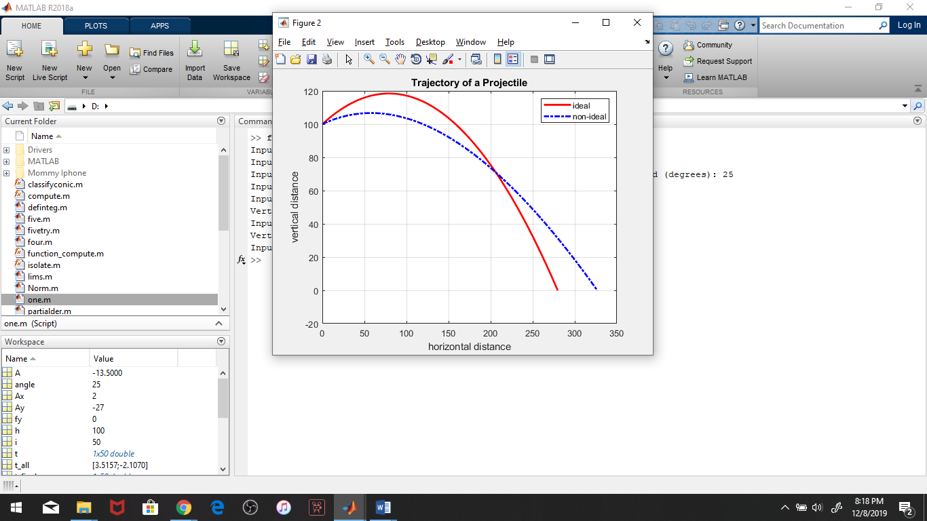

**Script file:**

